

**F30 Tip Sheet**

**(Dual Doctoral Degree)**

**eRA Commons/SIMS Access**

Contact Marybeth Brown [mbrown2@pennstatehealth.psu.edu](mailto:mbrown2@pennstatehealth.psu.edu) and Sarah Frey [sfrey@pennstatehealth.psu.edu](mailto:sfrey@pennstatehealth.psu.edu)

* Provide full name, email address, and title of applicant
* Assign the role of PI for the Fellow/Graduate Student
* Assign the role of Sponsor for the Mentor (faculty)
* Profiles **must** be completed/updated in eRA Commons. New users will receive an email from eRA Commons with instructions.
* Fellow/Graduate Student **must** link their [ORCID](https://era.nih.gov/erahelp/Commons/default.htm#orcid.htm%3FTocPath%3D_____29) account to their eRA Commons account.

**COINS**

Contact Marisa Klein [mklein1@pennstatehealth.psu.edu](mailto:mklein1@pennstatehealth.psu.edu)

**SIMS Budget – GL Codes**

1. Create a new “Traditional” budget

Refer to program announcement for specific details regarding length of support, allowable costs, etc.

1. Modify Rates – Change default F&A rate to Zero (0)
2. SIMS budget, enter Mentor as the PI and zero (0) dollars requested
3. Enter the Fellow – use GL 51158200 **(no fringe benefits and no F&A)**

* Refer to NRSA Stipend Table <https://grants.nih.gov/grants/guide/notice-files/NOT-OD-24-104.html>

1. Enter Tuition – use GL 52660201. (See next page for example)

* PhD – two semesters post-comp rate (using a 2% COL factor)
* MD – escalate current Med School rate by 2% COL calculate MD year tuition

Current Med School tuition found at <https://med.psu.edu/md/tuition>

1. Enter Institutional Allowance – use GL 52091100 (Description: enter Institutional Allowance)

* Refer to NRSA Notice for current **Institutional Allowance for Individual Fellows** <https://grants.nih.gov/grants/guide/notice-files/NOT-OD-24-104.html>

1. Per [NOT-OD-24-116](https://grants.nih.gov/grants/guide/notice-files/NOT-OD-24-116.html), PI can request $3,000 childcare costs per year (funds are restricted).   
   This is an optional expense, only include **IF** the PI wants to request. Use GL 52571000

**Create an IAF**

MD/PhD Students **ONLY** – Include Dr. Kirsteen Browning on the IAF

**Create Cayuse packet – FORMS H**

1. Create Cayuse packet. Use the Sponsor as the PI. DO NOT IMPORT THE BUDGET.
2. **Name the Student as the PI**
   1. Go to the RR Key Persons tab.
   2. Add the student as Senior/Key Person. Click on the pencil, type in their last name, search, and add the student. Save.
   3. Delete both your sponsor and student by click on the red X and save.
   4. Click on the pencil for the Project Director/Principal Investigator, type in the student’s last name and search. If the student has never submitted a grant, you need to change the “eRA Role Filter” to “Any/all (unfiltered)” and search. Select the student and save. This should now populate the student as the PI and on page 1 of the SF424.
   5. Click on the pencil to add the Sponsor
3. Page 2 SF424

* Block #15a & 15c – manually enter **Total Requested from Sponsor** from SIMS budget.
* Block 15b & 15d - manually enter 0.

1. PHS Fellowship Supplemental Form – **Budget Section**

* Tuition and Fees: Click on Funds Requested and manually enter tuition (**only tuition)** for each year requested. Note: The total will match the total on SIMS budget for tuition.
* No additional budget details are needed.

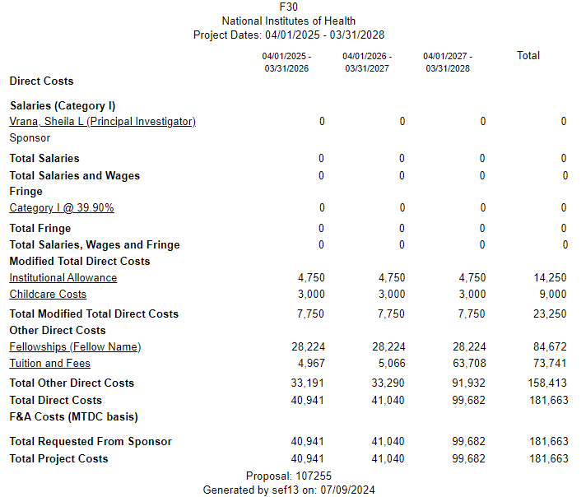

PhD portion = Post-Comp x 2 semesters

MD portion – Use Medical School rates – confirm current rates

**Example – Current Rates**

**Graduate School Tuition (PHD)**

(Post-Comp Rate for 2 semesters) with 2% COL

Year 1 – $4,967

Year 2 – $5,066

Year 3 – $5,167

Year 4 – $5,270

Year 5 – $5,375

**Medical School Tuition (MD)**

Current Rate (2024-2025) = $60,033

Year 1 – $61,234

Year 2 – $62,459

Year 3 – $63,708

Year 4 – $64,982

Year 5 – $66,282

**FORMS-H**

|  |  |
| --- | --- |
| https://infonet.pennstatehershey.net/documents/396359/398665/Penn+State+College+of+Medicine+Two+Color/40a62c56-8573-4036-b92a-a6c0b9bd9bc8?t=1456670291786 | PI (Applicant): ___________________________  **(Must be affiliated as “PI” role in eRA Commons**  **& have linked** [**ORCID ID**](https://era.nih.gov/erahelp/Commons/default.htm#orcid.htm%3FTocPath%3D_____29)**)**  Faculty Sponsor: _____________________  **(Must be affiliated as “Sponsor” role in eRA Commons)** |

**Parent F30** [**PA-23-260**](https://grants.nih.gov/grants/guide/pa-files/PA-23-260.html) **– Dual Doctoral Degree** Date Reviewed: __________

Admin Contact: _________________­­_____

**IAF # _________ SIMS Budget # __________ ISP # ____________**

**Note:** Include Dr. Kirsteen Browning on the IAF

_____ **SF424 (R&R) - Page 1 & 2**:

___ Type of Submission/Applicant Info.

___ UEI No./EIN No.

___ Dates of Proposed Project

___ Pg. 2: Estimated Project Funding (stipend, tuition/fees, & allowance only)

___ Cover Letter – include list of referees

**Letters of Reference**: 3-5 required. MUST be submitted through eRA Commons by the deadline.*

_____ **Project/Performance Site Location(s)**

___ UEI # ___ County ___ Cong Dist.

_____ **R&R Other Project Information**

___ Human Subjects (if yes, review instructions. For assistance, contact HSPO office)

___ Vertebrate Animals

___ Project Summary/Abstract – **30 lines**

___ Project Narrative – brief description

___ Bibliography/References Cited

___ Facilities & Other Resources

___ Include a detailed description of the institutional facilities & resources available to the fellowship applicant.

___ Equipment

___ Other Attachments: If Applicable

_____ **R&R Senior /Key Person Profile**

___ PI Commons user name – **Required for PI and Primary Sponsor (optional for co-sponsors)**

___ Biosketches – **Candidate-Use Form Page:** -5 pg limit – include pubs, course info and grades)

**Sponsors ONLY - List as:**

___ Role: “Other (specify)” & Sponsor or Co-Sponsor

___ Biosketch

**PHS 398** **Fellowship** **Supplemental Form:**

1.___ Introduction – (resubmission) **1 pg.**

**Fellowship Applicant Section:**

2.___ Applicant’s Background & Goals for Fellowship Training – **6 pg. limit**

**Research Training Plan Section:**

3.___ Specific Aims – **1 pg. limit**

4.___ Research Strategy – **6 pg. limit**

5.___ Respective Contributions – **1 pg. limit**

6.___ Selection of Sponsor & Institution – **1 pg. limit**

7.___ Progress Report Publication List (renewal only)

8.___ Training in the Responsible Conduct of Research – **1 pg. limit**

**Sponsor(s), Collaborator(s), & Consultant Section:**

**Per RFA:** If the applicant is proposing to gain experience in a clinical trial as part of his/her research training, the sponsor (co) must include a statement to document leadership of the clinical trial including source of funding, NCT# & appropriate expertise to guide the applicant in any proposed clinical trials research exp.

9.___ Sponsor & Co-Sponsor Statements – **6 pg. limit**

10.___ Letters of Support – **6 pg. limit**

**Institutional Environment & Commitment to Training:**

11.___ Description of Institutional Envir. & Commit. to Training – includes Educational information, structure of Grad program, etc. – **2 pg. limit.** **See** [**PA-18-668**](https://grants.nih.gov/grants/guide/pa-files/PA-18-668.html)

**Note:** Include statement from Dr. Browning

**Other Research Training Plan Section:**

12.___ Description of Candidate’s Contribution to Program and Goals (if applicable)

13-14. ___ Vertebrate Animals

15.___ Select Agent Research

16.___ Resource Sharing Plan

17. ___ Other Plan(s) – Not required for Fellowships

18.___ Authentication of Key Biological and/or Chemical Resources

**Additional Information Section:**

19.___ Human Embryonic Stem Cells

20.___ Alternate Phone Number

21-26. ____ Additional Information Section

**Budget Section:**

27.___ Tuition & Fees Only – **No F&A**

See Notice: [NOT-OD-24-104](https://grants.nih.gov/grants/guide/notice-files/NOT-OD-24-104.html)

28.___ Childcare Costs

(Continued on Reverse Side)

**Senior Fellowship Applicants ONLY:**

29-30. ___

**31. ___ Appendix**

**_____ PHS Assignment Request Form**

**Note: This FOA is designed for applicants proposing research that does not involve leading an independent clinical trial, a clinical trial feasibility study, or an ancillary study to a clinical trial, but does allow applicants to propose research experience in a clinical trial led by a sponsor or co-sponsor.**

____ **PHS Human Subjects and Clinical Trials Information**

**___ If NO to Human Subjects:** Does proposed research involve human specimens and/or data? (If yes, provide explanation)

**___ If YES to Human Subjects:** Add a record for each proposed Human Subject Study

**NOTE: Study Title cannot exceed 600 characters/spaces**

**___ Other Requested Information** – if applicable

**____ Inclusion Enrollment Report**

**____ Protection and Monitoring Plans**

**N/A Protocol Synopsis – see PA-19-191**

**N/A Other Clinical Trial-related - see PA-19-191**

### N/A PHS Human Subjects and Clinical Trials Information – To be used only for multi- project applications

For projects containing IT components (e.g., new equipment, data collections, network connectivity),

contact [askPSHealthIT@psu.edu](mailto:askPSHealthIT@psu.edu) or call x280250

**Format:** Be Consistent

___ Unallowable hyperlinks – see [**NOT-OD-20-174**](https://grants.nih.gov/grants/guide/notice-files/NOT-OD-20-174.html)

___ pdf documents

___ File names: **no spaces, or special characters –** 50 characters or less

___ At least ½” margins

___ No headers/footers

___ Allowable fonts and sizes – See [NOT-OD-17-030](https://grants.nih.gov/grants/guide/notice-files/not-od-17-030.html)

**Reminders:**

**SUBMIT EARLY –**

**No More Two Day Correction Window**

**ORA Deadlines:**

**1st Review** To ORA 5 working days prior to application receipt date.

**Final** To ORA 24 hours prior to application receipt date.

**Consistency** - Remember to check budget, and project dates throughout.

**Additional Notes:**

Additional Award Budgetary Information: For Kirschstein-NRSA stipend, tuition, and fees policy/notices, see: [NRSA research training information](https://researchtraining.nih.gov/resources/policy-notices)

**\*Letters of Reference**: See <https://grants.nih.gov/grants/how-to-apply-application-guide/submission-process/reference-letters.htm> for the guidelines regarding fellowship reference letters.

**Public Access Policy & SciENcv** –

<http://publicaccess.nih.gov/index.htm>

<http://publicaccess.nih.gov/communications.htm>

**Single IRB (sIRB) & Reliance Requests**

<https://research.med.psu.edu/research-support/irb-hspo/single-irb/>

**Foreign Influence Disclosure**

<https://www.research.psu.edu/international_affiliations>

**Export Control**: Foreign component or foreign involvement requires an export review. **Must** be indicated on IAF – Export tab.

[](http://www.google.com/url?sa=i&rct=j&q=&esrc=s&source=images&cd=&cad=rja&uact=8&ved=2ahUKEwiEnv_-7JHiAhViT98KHdpDBSkQjRx6BAgBEAU&url=http://cliparting.com/free-june-clipart-34660/&psig=AOvVaw1OQ3GHqAmEeglOF1p8xrCm&ust=1557608229796926)

**NIH Policy for Data Management and Sharing:** [**NOT-OD-21-013**](https://grants.nih.gov/grants/guide/notice-files/NOT-OD-21-013.html)